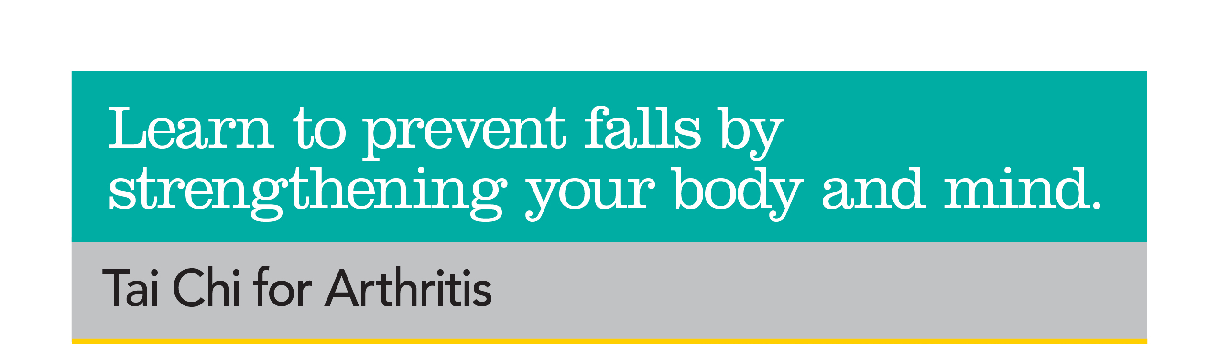

******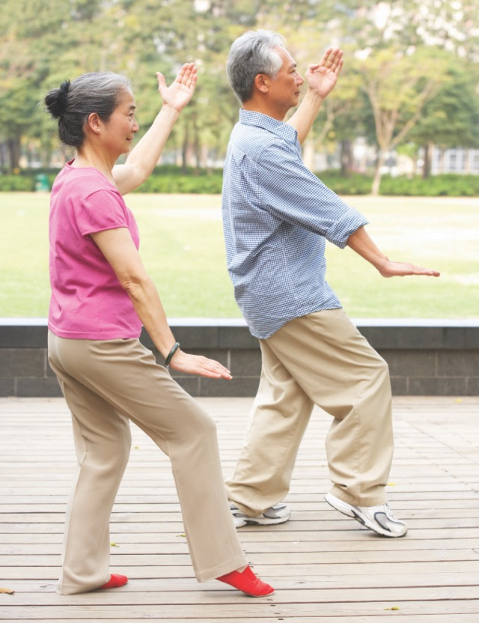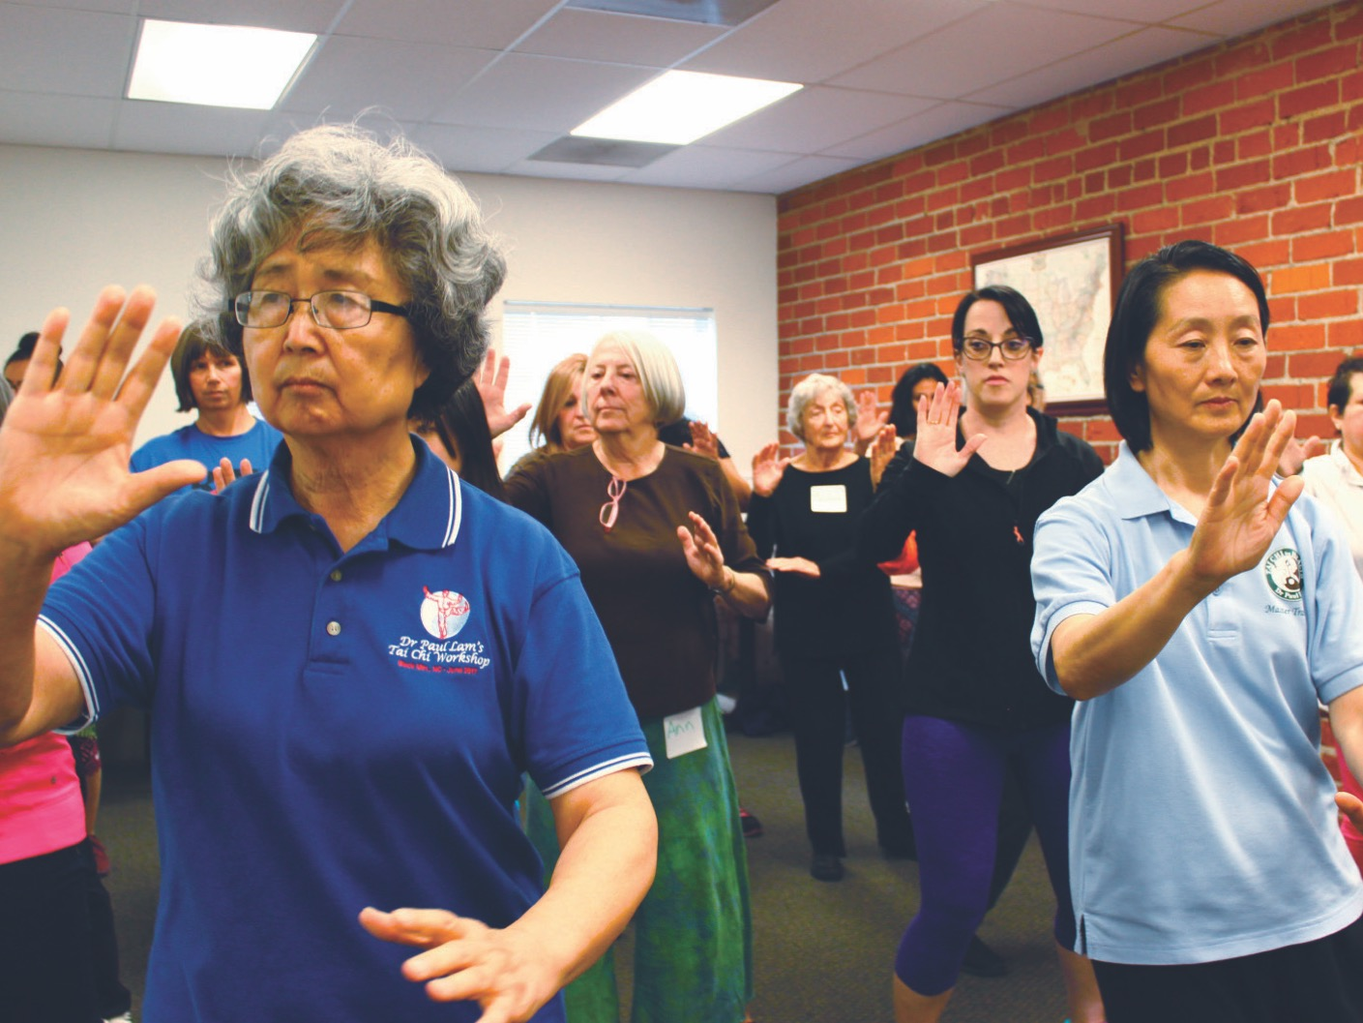

**Just because you have arthritis doesn’t mean**

**you can’t enjoy the many benefits of gentle**

**Tai Chi exercise.**

All six core basic movements in the Tai Chi Sun Style

• Arthritis-friendly movements modified for mobility

• Relaxing breathing techniques

• Tai Chi principles that build balance of mind and body

**Time:**

**Contact:**

**Location:**

**Dates:**

***Space is limited. Sign up NOW for 20 FREE one hour sessions!***

• Better balance

• More strength

• Improved range

of motion

• Increased flexibility

• Enhanced

psychological health

• Decreased pain

• Prevented falls

• One or two Tai Chi movements per session

• All six core basic movements in the Tai Chi Sun Style

• Arthritis-friendly movements modified for mobility

• Relaxing breathing techniques

• Tai Chi principles that build balance of mind and body

DISCLAIMER: This project was supported, in part by grant number 90FPSG0005-01-02, from the U.S. Administration for Community Living, Department of Health and Human Services, Washington, D.C. 20201. Grantees undertaking projects under government sponsorship are encouraged to express freely their findings and conclusions. Points of view or opinions do not, therefore, necessarily represent official Administration for Community Living policy.