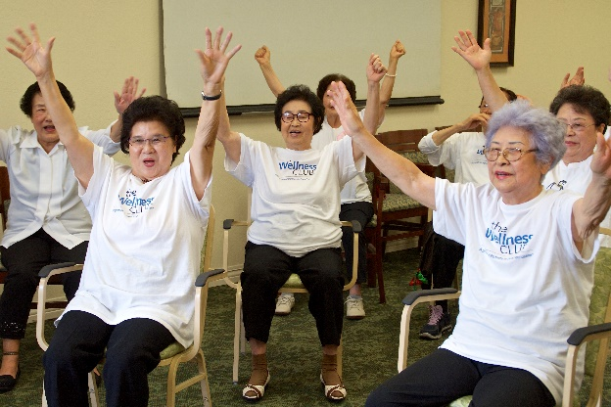

**Arthritis Foundation**

**Exercise Program**

**Brought to you by**

**Partners in Care Foundation**

**For Participants 60+ Please sign up at the front desk!**

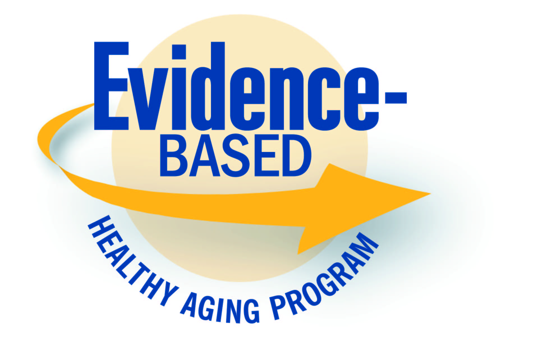

**Who should attend?**

Anyone who has been diagnosed with arthritis or who routinely experiences joint pain, stiffness, and/or limited range of motion is invited to attend. Exercises may be performed sitting or standing.

**Take Control with Exercise!**

**The Arthritis Foundation Exercise Program** is an evidence-based program. The movements were developed by physical therapists to address the pain, fatigue, and decreased strength that often accompany chronic illness. The routines use gentle range-of-motion movements that are suitable for every fitness level and can be taken sitting or standing.

**Benefits of the program include:**

* Decreased pain
* Improved overall health status
* Increased flexibility & range of motion
* Increased energy
* Better, more relaxed sleep
* Improved outlook

Classes take place twice a week for six weeks and last about an hour. The routines can be quickly learned for easy adaptation at home.

**Sign up now!**

**Contact:**

**Location:**

**Time:**

**Dates:**

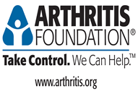

**_________________________________________________________________________________________________________________**

The Arthritis Foundation Exercise Program is offered through the Health Innovation Programs department of Partners in Care Foundation. Partners in Care Foundation is the state project office for the California Department of Aging, providing ongoing technical support to sites and leaders offering evidence-based programs.